

**Sukkur Institute of Business Administration University**

Department of Electrical Engineering

**Introduction to Robotics, Fall 2023**

**Semester Project Fall - 2023**

**Project Name**

**Emg Based Prosthetic Hands**

Group Members:

**1. Wakeel Ahmed (033-19-0026)**

**2. Muhammad Qasim (033-20-0009)**

**3. Habib Ullah (033-20-0026)**

Instructor: **Dr: Afaque Manzoor Soomro**

Certificate

*It is certified that Mr.* ***Wakeel Ahmed****,* ***Muhammad Qasim, and Habib Ullah*** *having CMS ID’s* ***(033-19-0026), (033-20-0009) and (033-20-0026)*** *are the students of* ***BE-VII(Electronics)*** *have carried out the “****Semester Project****” for the subject* ***of Introduction to Robotics*** *as provided by the Instructor of the subject at the department of Electrical Engineering, Sukkur Institute of Business Administration for* ***Fall - 2023.***

Date: 28/12/2023 Instructor’s Signature

**Table of Contents**

1. Introduction
2. Components Required
3. Schematic
4. Working principle
5. Code
6. Conclusion
7. References

**Abstract:**

The goal of this semester's project is to develop electromyography (EMG)-based prosthetic hands, which will control of prosthetic hand by utilizing the complex signals produced by muscle contractions. The project's goal is to create a natural-feeling, responsive prosthetic hand that the user can easily operate by detecting and interpreting EMG signals. The objective is to increase the accuracy and adaptability of prosthetic hand movements by combining cutting-edge signal processing techniques with creative prosthetic design, ultimately improving the quality of life for people who have lost limbs. The project creates a state-of-the-art prosthetic limb solution by combining signal processing, biomechanics, and engineering.

1. **Introduction**

In the future, imagine hands that are artificial and have real-like movement. We're exploring into the world of prosthetic hands this semester. These hands comprehend signals from muscles in addition to obeying commands! Your muscles speak, and the hand pays attention—it's like magic. To make this happen, we're combining engineering and medical expertise with advanced technology. The objective is to provide a natural-feeling, who are missing limbs. Come look into us the future of technology.

1. **Components Required**

|  |  |  |  |
| --- | --- | --- | --- |
| **Components** | **Quantity** | **Price** | **Links** |
| Arduino Uno | 01 | Rs 1,900 | <https://digilog.pk/products/arduino-cable?variant=44491093606678> |
| Muscle Sensor Module | 01 | Rs 3,300 | <https://digilog.pk/products/muscle-sensor-module-for-arduino-specially-designed-for-microcontrollers?_pos=1&_sid=536eb64e7&_ss=r> |
| Camelion 9v Battery Super Heavy Duty | 02 | Rs 250*2=500 | <https://digilog.pk/products/camelion-6f22-9v-battery-super-heavy-duty?variant=44490726211862> |
| Towerpro Sg90 Sg 90 180 Degree Servo Motor | 01 | Rs 280 | <https://digilog.pk/products/towerpro-sg90-sg-90-180-degree-degree-servo-motor-in-pakistan?_pos=1&_sid=5637e294c&_ss=r> |
| 9 Volt Battery Snap Connector | 02 | Rs 25*2=50 | <https://digilog.pk/products/9-volt-battery-snap-connector?_pos=1&_sid=5f394e607&_ss=r> |
| Connecting Wires | As required | Rs 140 | <https://digilog.pk/products/10cm-pin-to-hole-jumper-wire-dupont-line-40-pin-male-to-female-arduino-jumper-wires-in-pakistan?_pos=11&_sid=57f99d9ad&_ss=r> |

1. **Schematic:**

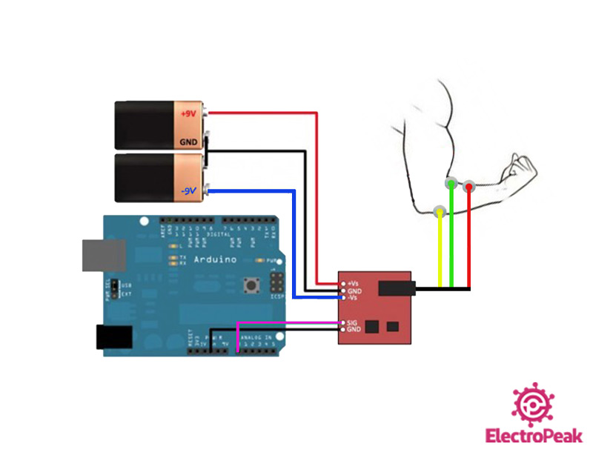

1. **Working Principle**

The working principle of EMG-based prosthetic hands hinges on the remarkable communication between muscles and technology. When you think about moving your hand, your muscles generate tiny electrical signals. We place sensors on the skin that pick up these signals when muscles contract or relax. These signals are then sent to an Arduino Uno that decodes them into specific hand movements. It's like teaching the prosthetic hand to understand your muscle language. A prosthetic hand that moves by the signals from your own muscles.

1. **Code:**

|  |
| --- |
| #include <Servo.h>  // Define the pin for the EMG module input  #define EMG_PIN A1  // Create a Servo object  Servo myservo;  // Define the threshold for muscle activity  #define ACTIVITY_THRESHOLD 121  void setup() {    // Attach the servo to pin 9    myservo.attach(3);    // Set up the serial communication    Serial.begin(9600);  }  void loop() {    // Read the EMG module input    int emgValue = analogRead(EMG_PIN);    // Check if muscle activity is detected    if (emgValue > ACTIVITY_THRESHOLD) {      // Muscle activity detected, change direction      myservo.write(90);    } else {      // No muscle activity, return to the original position (0 degrees)      myservo.write(0);    }    // Print EMG value for debugging    Serial.print("EMG Value: ");    Serial.println(emgValue);    // Add a small delay to avoid excessive readings    delay(500);  } |

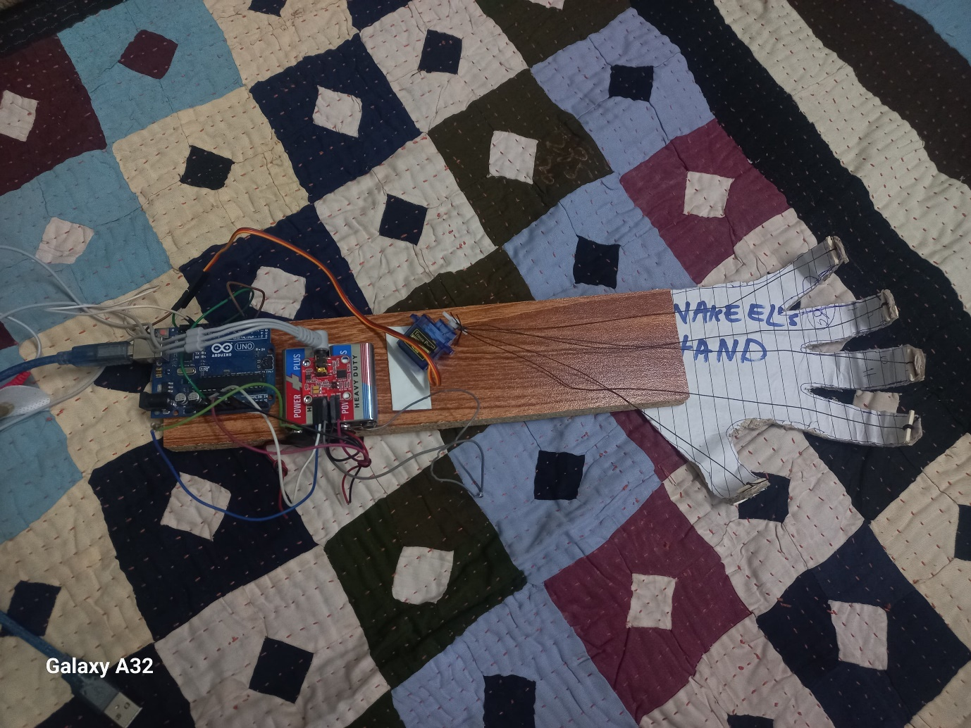



1. **Conclusion:**

In conclusion, EMG-based prosthetic hands offer a promising solution for individuals with limb loss, providing a more natural and intuitive way to control artificial limbs. By utilizing signals from muscles, these prosthetics enhance user interaction and functionality. The technology shows great potential in improving the quality of life for prosthetic users, allowing for more precise and personalized control. As advancements continue, EMG-based prosthetic hands represent a significant step forward in making artificial limbs more seamlessly integrated into the daily lives of individuals with limb challenges.

1. **References:**

[**https://www.tutorialspoint.com/arduino/arduino_dc_motor.htm**](https://www.tutorialspoint.com/arduino/arduino_dc_motor.htm)

[**https://www.slideshare.net/mafazahmed/speed-control-of-dc-motor**](https://www.slideshare.net/mafazahmed/speed-control-of-dc-motor)

[**https://www.electronicshub.org/speed-and-direction-control-of-dc-motor-using-arduino/**](https://www.electronicshub.org/speed-and-direction-control-of-dc-motor-using-arduino/)